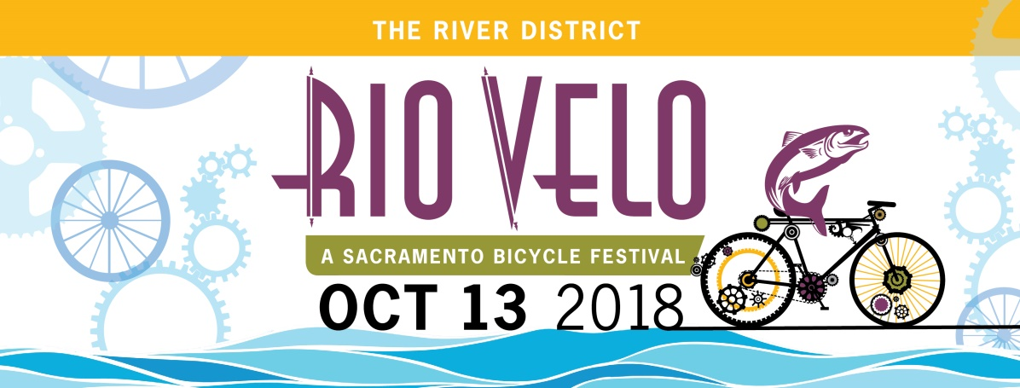

July 23, 2018

FOR IMMEDIATE RELEASE

Contact: Ian B. Cornell
Cornell Group
(916) 965-1805
icornell@cornellgroup.com

Rio Velo Bicycle Festival Returning to Sacramento in October
The annual Rio Velo bicycle festival will return to Township 9 Park in the River District, October 13 from 11 a.m. to 4 p.m. A free festival that celebrates bicycles, the rivers and the people who love them, Rio Velo is created to attract recreational riders, bicycle commuters, specialty riders, seasoned cyclists and all who enjoy bicycling for transportation, recreation and healthy living.
The event will feature live music, daredevil stunts, bike safety training, a bike rodeo, activities for kids, electric bike test rides, and SactoMoFo food and brew.

Rio Velo
Saturday, October 13
11 a.m. to 4 p.m.
Township 9 Park
(at the American River and North 7th Street,
along the Two Rivers Bike Trail)

For more information, visit the website at RioVelo.com.
# # #

