REGISTER NOW
https://www.eventbrite.com/e/nasa-space-apps-challenge-sacramento-2022-make-space-tickets-399468871147
OCTOBER 1-2, 2022 A REGIONAL EVENT IN FOLSOM

Mark your calendar for this free and engaging weekend of fun for ALL ages!
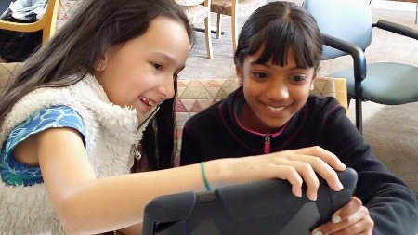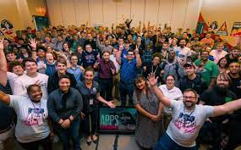
On October 1-2, 2022 NASA is inviting coders, entrepreneurs, artists, scientists, designers, storytellers, makers, builders, and technologists to come together in a GLOBAL HACKATHON. Over two days, participants from around the world will create in-person and virtual teams to solve challenges using NASA’s open-source data. Since 2012 NASA Space Apps has engaged over 180,000 participants from 150+ countries.
The World Needs YOUR Ideas
Here is the link to the NASA Space Apps Challenge challenges for review
Challenges - Space Apps Challenge | 2022
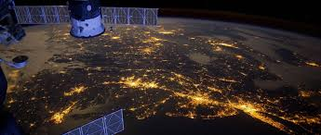
Reach us to participate, sponsor and more: NASAchallengeSAC2022@gmail.com

